Claveria, Jorlyn Shane M.
BS INFO 3C
NAS 3 – Finals_Lab 1

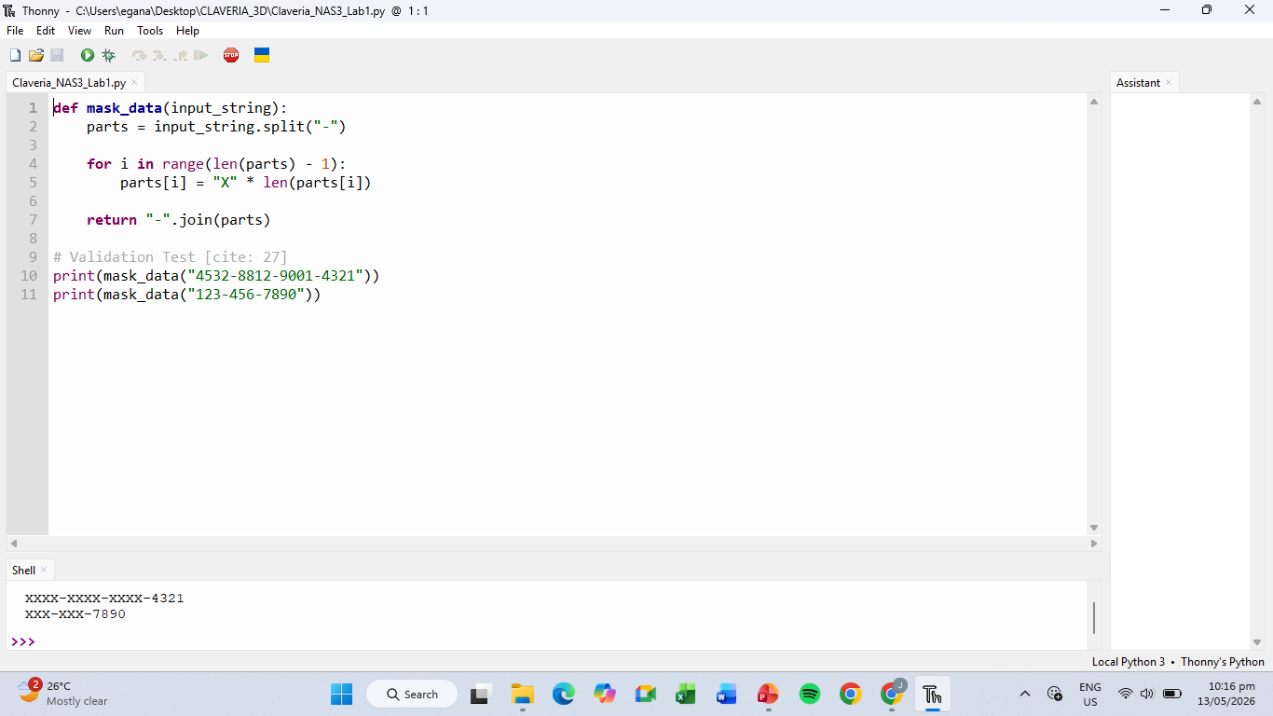
- Documentation

This shows the successful implementation and execution of a Python script designed for data masking within the Thonny code editor. The source code defines a function that splits an input string by hyphens, replaces all but the last segment with "X" characters, and re-assembles the parts to protect sensitive information. Below the code, the shell window displays the validation test results, showing a credit card number and a phone number correctly masked while preserving their original structure.

